**Horror House Sound Plan**

Evan Svendsen

Sound List:

3D:

* **Creaky Gate (Open)**: Plays when the gate is opened. Triggered with box collider.

*Sourced from Tech Skull Studios purchased assets*

* **Creaky Gate (Close)**: Plays when the gate is close. Triggered with exit of box collider.

*Sourced from Tech Skull Studios purchased assets*

* **Rustling Leaves**: Plays on loop in the background while outside the house

<https://lethbridgecollege-my.sharepoint.com/personal/peter_gingras_lethpolytech_ca/_layouts/15/stream.aspx?id=%2Fpersonal%2Fpeter%5Fgingras%5Flethpolytech%5Fca%2FDocuments%2FRadio%20Station%20Music%20%26%20%20SFX%2FExtra%20SFX%2FSFX%5FLEAVES%20IN%20WIND%2Ewav&referrer=StreamWebApp%2EWeb&referrerScenario=AddressBarCopied%2Eview%2Edc63f35a%2De6c6%2D4fd5%2Db724%2Da91b8545fe83>

* **Main Door Open**: Played automatically when the main entrance doors are opened

*Sourced from Tech Skull Studios purchased assets*

* **Main Door Open**: Played automatically when the main entrance doors are closed

*Sourced from Tech Skull Studios purchased assets*

* **Main Door Shut**: Played automatically when the main entrance doors are shut

*Sourced from Tech Skull Studios purchased assets*

* **Airlock Guest & Power Room**: Loops in the background the entire game with a very low volume so that it overlays on top of any other sounds being played. Mixed together with an audio mixer that transitions between outside and inside zones.

*Vertigo - Ambience - Horror & Suspense - Atmosphere - Moods*

* **Supernatural Demonic Voices**: Plays randomly in sequence on the demon model sitting in the chair. When one sound finishes, it will select a random new sound to play

*Vertigo - Ambience - Horror & Suspense - Voices - Supernatural - Demonic*

* **Grandfather Clock Ticking**: Plays on loop. Player will hear this sound when approaching the clock

*Sourced from Tech Skull Studios purchased assets*

* **Door Creak (Open)**: Played automatically when doors in the house are opened

*Sourced from Tech Skull Studios purchased assets*

* **Door Creak (Close)**: Played automatically when doors in the house are closed

*Sourced from Tech Skull Studios purchased assets*

* **Organ Drone**: Loops on the piano.

*piano_impression1.aif by thanvannispen -- https://freesound.org/s/30274/ -- License: Attribution 4.0*

* **Light Flicker**: Lamp in the front entrance will randomly flicker when the player approaches it. Lamp flicker sound plays while the lamp is flashing. Also played on upstairs bedroom light and lights along the wall

*Flickeringlight.aiff by scotchio -- https://freesound.org/s/143915/ -- License: Creative Commons 0*

* **White Noise**: Upon entering the murder room, the white noise will be triggered by the box collider.

*Sourced from Tech Skull Studios purchased assets*

* **Ship Sounds**: Randomly played in a playlist on loop in the bathroom

*Sourced from Tech Skull Studios purchased assets*

2D:

* **UFO Drone**: Loops in the background the entire game with a very low volume and in 2D space so that it overlays on top of any other sounds being played

*Vertigo - Ambience - Horror & Suspense - Tension - Drones - UFO Drone*

* **Footstep Sounds (Outside & Inside)**: Play while the character is walking through the house and outside

*Sourced from Tech Skull Studios purchased assets*

* **Collect Sound**: UI sound plays when the player picks up the religious artifacts

*Sourced from Tech Skull Studios purchased assets*

* **Game Over Sound**: UI sound plays when the player brings all artifacts to the murder room and lifts the curse

*Sourced from Tech Skull Studios purchased assets*

* **Audio Narration**: Plays at the start of the game. Describes the gameplay and goal and win condition. Recorded by myself

*Recorded By Myself*

* **Ghost Screams**: Played when the ghost appears

*Vertigo - Ambience - Horror & Suspense - Voices – Human-like*

* **Jump Scare**: Played when the ghost appears

*Piano Jump Scare Stinger by TheSoundFXGuy_YT -- https://freesound.org/s/534218/ -- License: Attribution 4.0*

Rooms:

**Outside**:Player will spawn here and enter the house. Plays the sound of leavesin the background. Open space sound does no reverberate off surfaces instead dissipates fast. Creaky gate sound played when entering.

**Main Entrance**:Loop on the grandfather clock. Player will enter the house at this location. Closed space the sound will be slightly absorbed by the surrounding walls. Lamp flickering sound on the lamp to the right. Door opening sound will be played when entering.

**Upstairs Bedroom**:Player must ascend the stairs that go to the left. Enter the room immediately in front and the **cross** will be sitting on the bed. Light flickering sound plays on the ceiling lamp.

**Upstairs Bathroom**: Player will ascend the stairs that go to the right. Enter the room and collect the **Bible** located on the shelves near the sink. Window is open and the sound of leaves will be heard from the outside through the open window. Ship sounds loop in the bathroom.

**Kitchen**:Tangentially connected to the main entrance + grand staircase. **Holy water** can be found in this room on the kitchen countertop. Lots of metal objects will cause the sound to reflect more than in other rooms.

**Fireside Room**:Tangentially connected to the piano room. Demon sits in the chair pointing to the murder room. **Exorcist Stak**e found in this room inside of the fireplace.

**Final Room (Piano Room)**: Where the murder occurred. Player must bring the religious objects collected to this room to lift the curse. Static white noise will play very quiet in the background in this room. Triggered when entering with a box collider. The white noise indicates the place between worlds where the rift has been opened by the curse.

Layout:

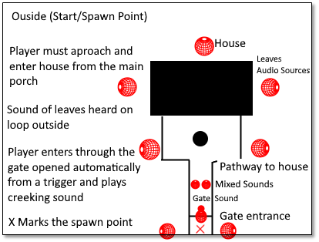

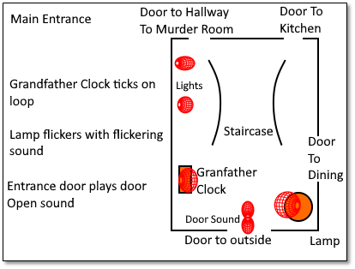

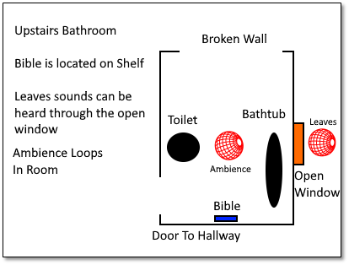

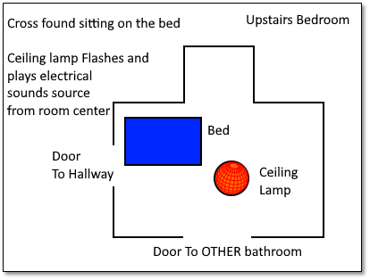

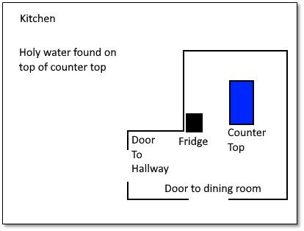

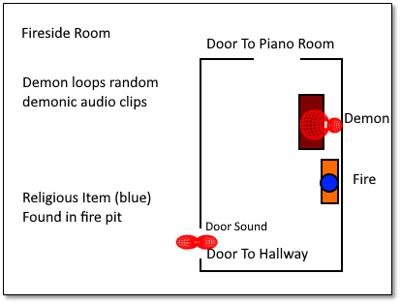

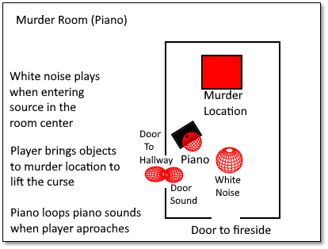

Story:

A girl has been murdered in the piano room and you are sent in to lift the curse. Player is made aware of this through narration at the start of the game. Your character has been sent to lift the curse upon the house. The child’s spirit haunts the house.

Gameplay:

Player must find 4 religious artifacts hidden throughout the house + scene outside and bring them to the murder room to lift the curse on the house.

Religious Objects:

* Cross
* Bible
* Holy Water
* Exorcist Stake

Bonus Marks: I did not find 5 sounds for each of the 7 rooms, but some sounds are comprised of mixing several together and I have multiple lists of random audio sounds that play. I have a mixer region when entering the house, as well as a mixer in the bathroom to increase the sound of leaves.

😊